Python Working and Notes
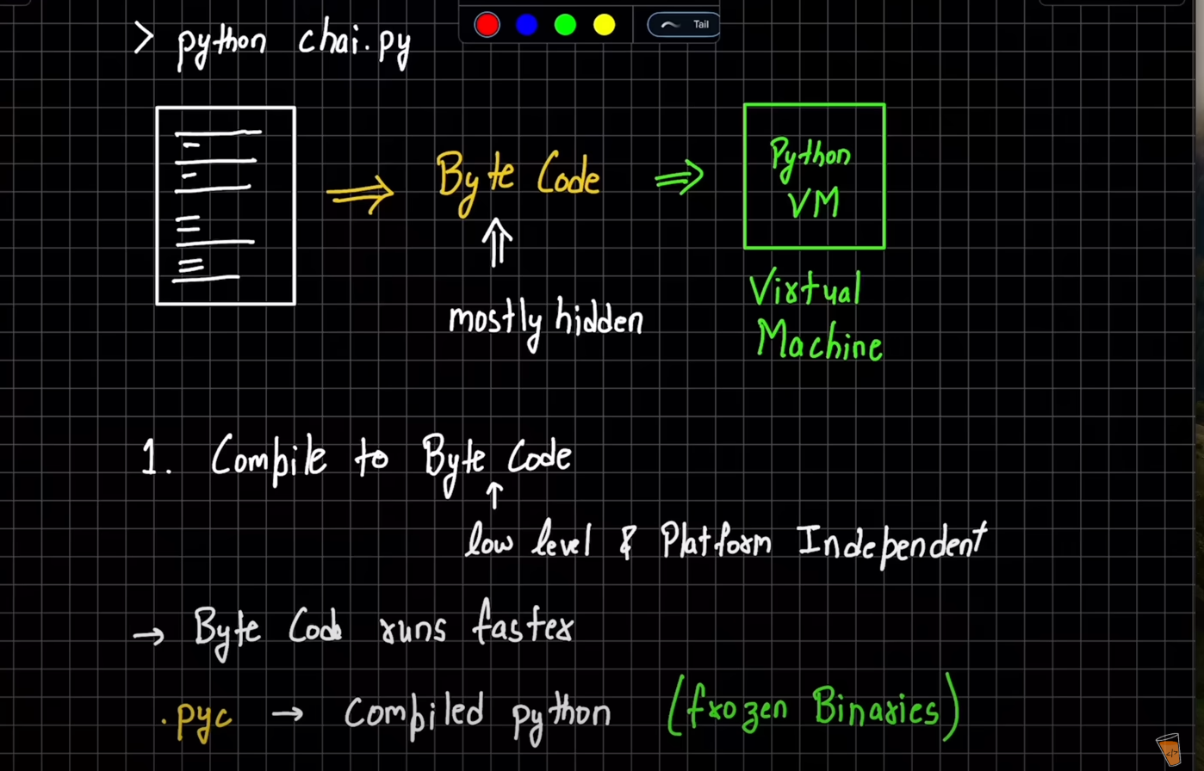
-> 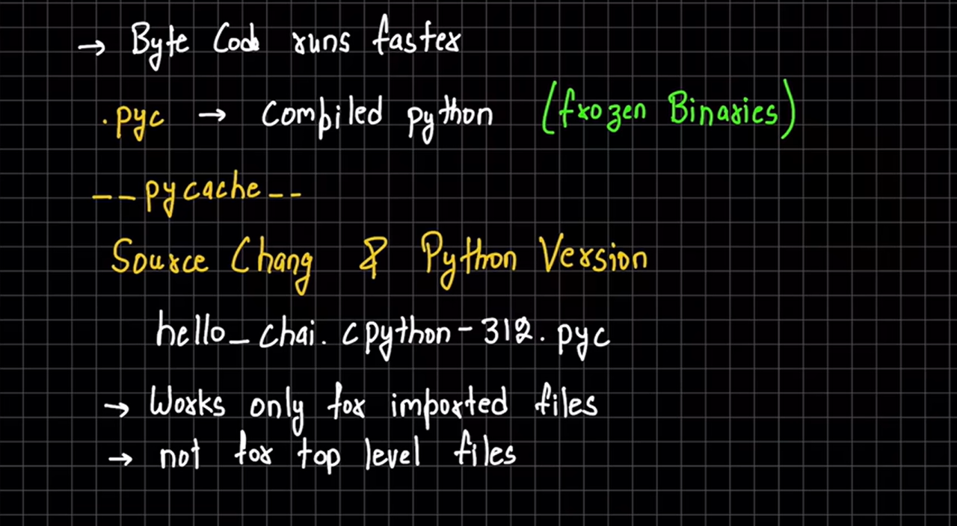
->Python virtual machine(PVM)
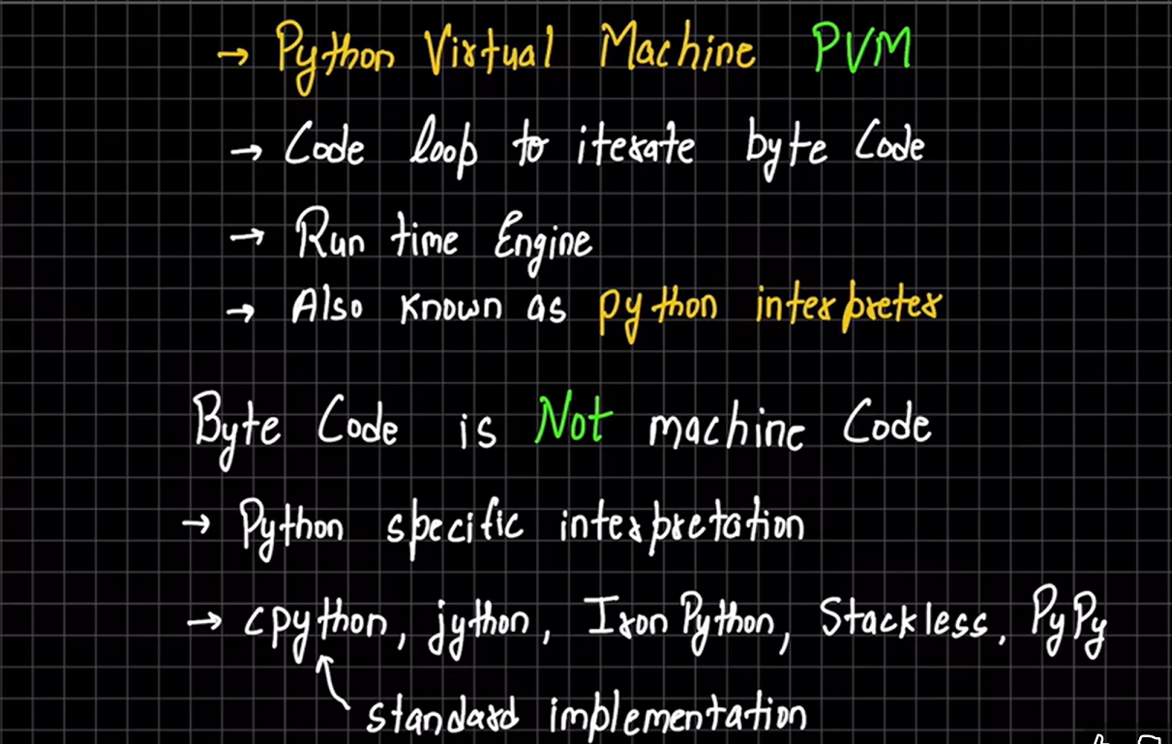

- Java is considered a compile language and python is not considered a compile language because java meh hame explicitly file koh compile karna tha and infront of us hum useh .java seh .class meh convert hote huye dekh sakte hai par python meh hame explicity compile nahi karna padhta .pyc(frozen binary) meh vo ek background process and its not mandatory to convert to byte code because if there is only a top level file(only 1 file which is executing there is no import used) than python virtual machine can directly run the file.
- Python Shell:- so agar hame python shell use karna hai usko hum python keyword terminal seh start kar sakte hai and idhar hum apni testing kar sakte hai by using variables ,function calling and loop and also we can import different modules in the python shell via import statement

** so basically to reload the imports agar hamare changes dynamic hore hai useh module meh to hum importlib seh reload import kar skate hai and with reload() hum useh module koh call kar sakte hai syntax- from importlib import reload
reload(module_name)
**
-> Mutable and Imutable in python:-
so basically jabh bhi hum mutable aur e mutable types keh baat karte hai python meh toh uska matlab yeh hota hai keh agar e.g hame ek variable liya usme pehle save kiya name = ”piyush” and uske baad hamne name = ”Piyush Sharma ” kardiya toh agar variable imutable type hai toh basically name joh hai vo Piyush vale memory block koh point naah karke Piyush Sharma wale memory block koh point Karega joh memory block hai jisme Piyush hai hum usme changes nahi kar sakte
but agar datatype mutable hogi toh hum useh memory block keh andar keh data koh change kar sakte hai also hum useh variable meh dusri value bhi store kar sakte hai

So in the nutshell mutable and immutable meh difference yeh hai keh hum immutable datatype meh different memory block koh refer kara sakte hai apne variable koh par useh memory block keh andar meh data koh change nahi kar sakte hai Par mutable datatype meh hum different memory block koh toh refer karva hi sakte hai apne variable koh sath hi sath useh memory block keh andar keh data koh vi change kar sakte hai
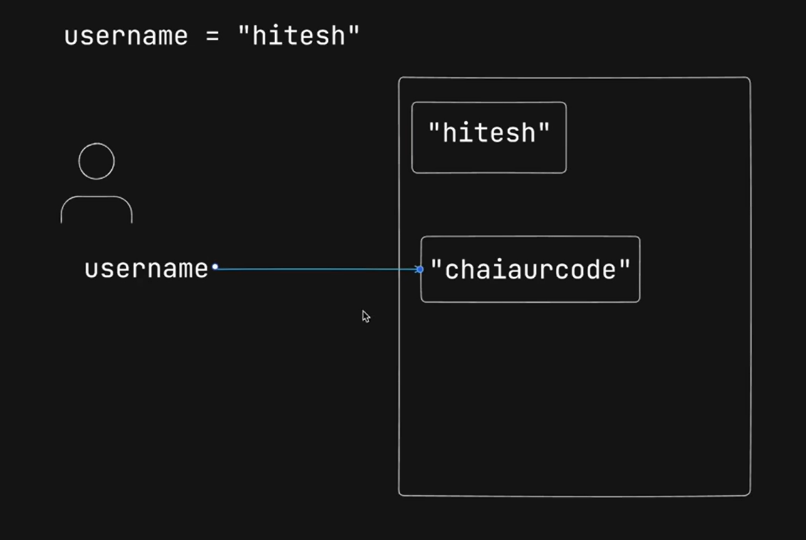

Toh basically jabh koi bhi reference variable useh memory block koh refer nahi kar raha hoga to garbage collector useh memory block koh clean kar dega

- x = 10
y = x
x = 15
print( x,y )
so basically yaha par output y =10 aayega iska reason yeh hai keh pehle y=x meh y and x dono 10 koh refer kar rahe theh jabh hamne x =15 kiya toh x neh 15 koh refer karna shuru kardiya par y toh tabh bhi 10 koh hi refer kar raha tha so that’s why x meh 15 aayega and y meh 10
